Victor Nguyen

Professor Hadaegh

CS 443

5 February 2020

Lab 2

**Question 1:**

1. **Create your ERD.**

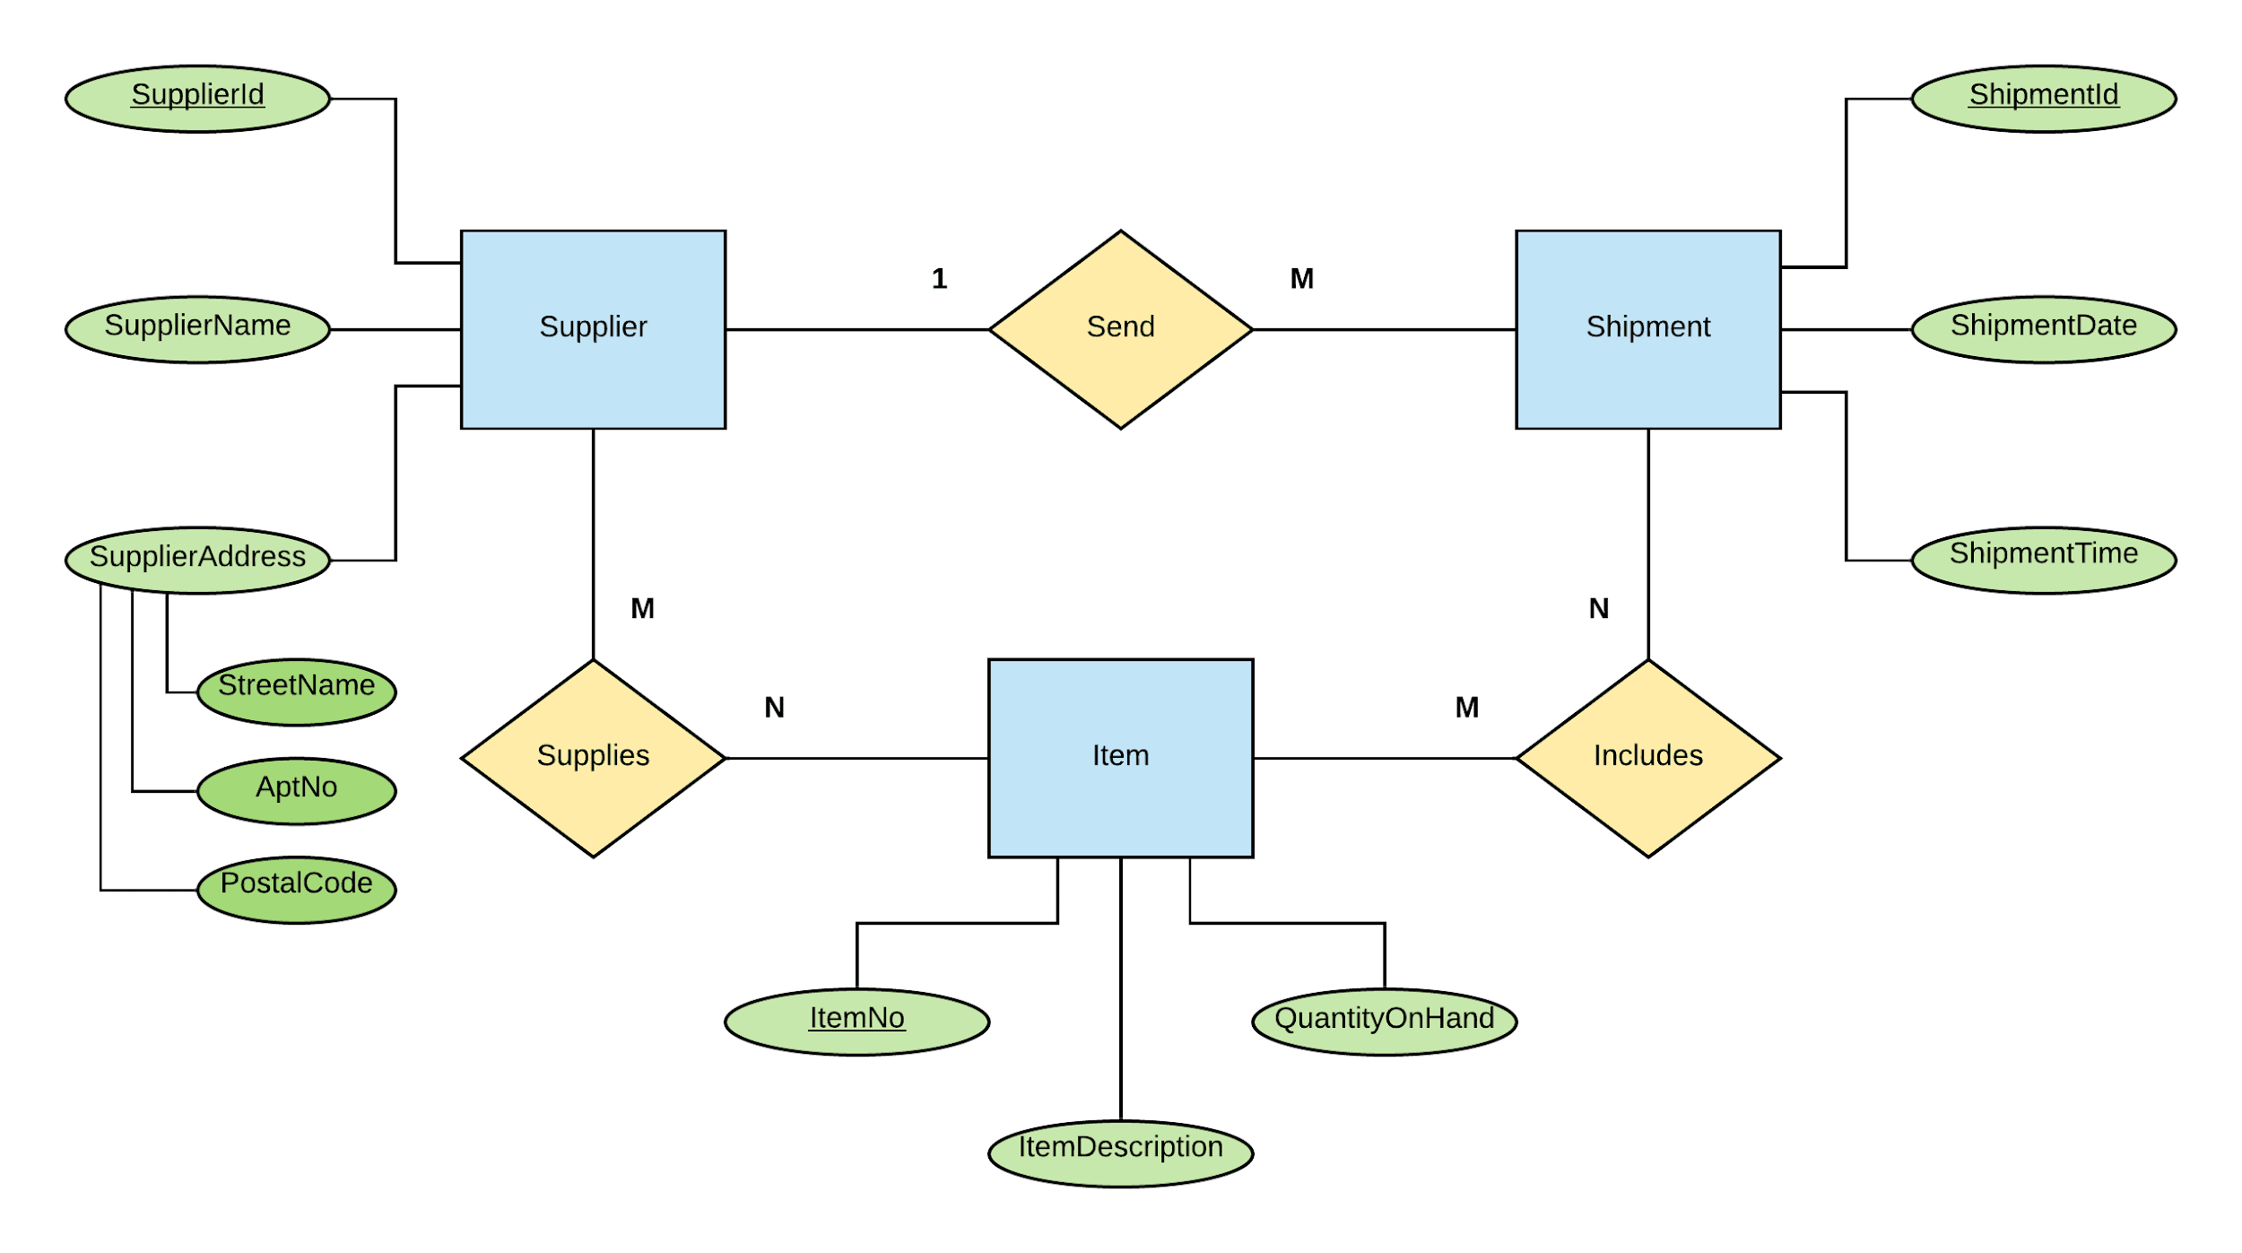

1. **Create associated tables.**

|  |
| --- |
| **Legend:** Attribute = Primary Key  Attribute* = Foreign Key |

Table 1: Supplier(SupplierId, SupplierName, SupplierAddress, StreetName, AptNo, PostalCode)

Table 2: Shipment(ShipmentId, ShipmentDate, ShipmentTime, SupplierId*)

Table 3: Item(ItemNo, ItemDescription, QuantityOnHand)

Table 4: Supplies(SupplierId*, ItemNo*)

Table 5: Includes(ShipmentId*, ItemNo*)

**Question 2:**

**Provide the tables for the following ERD.**

|  |
| --- |
| **Legend:** Attribute = Primary Key  Attribute* = Foreign Key |

Table 1: Department(D-Id, D-name, D-Loc)

Table 2: Major(M-name, D-Id*)

Table 3: Course(C-CRN, C-name, C-des, F-Id*)

Table 4: Student(St-Id, S-name, S-age, S-email)

Table 5: Faculty(F-Id, F-name, F-major, F-Office, D-Id*)

Table 6: Dependent(name, Gender, age, F-Id*)

Table 7: Takes(St-Id*, C-CRN*)